Make: | Plate /plant No: |  |  |  |  | Date: From / / 2025. To / / 2025
BACKHOE LOADER | SKIDSTEER LOADER |  |  |  | DUMPER | EXCAVATOR |  |  |  | FORKLIFT | DUMP TRUCK
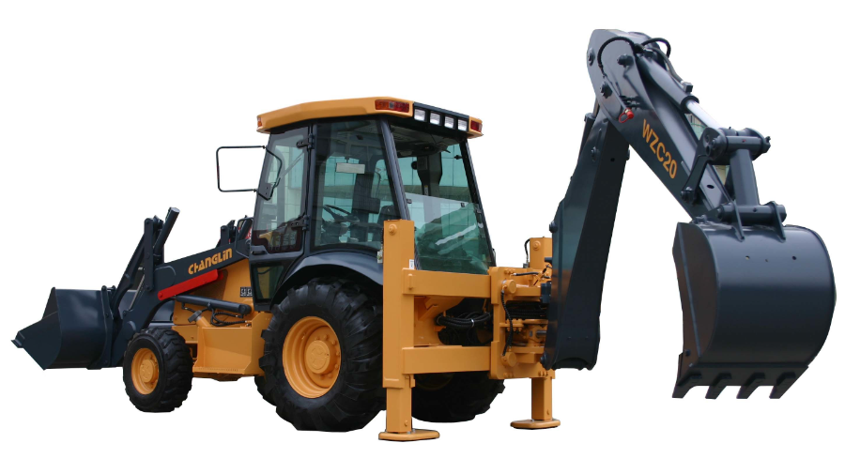 | 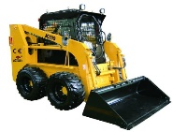 |  |  |  | 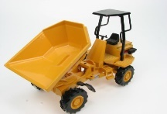 | 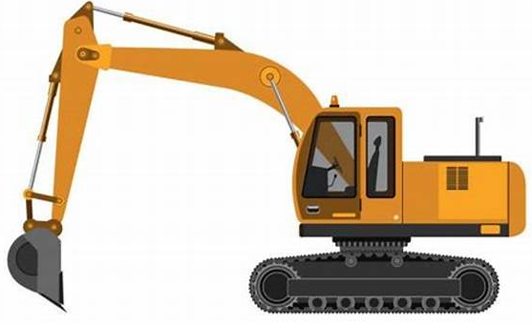 |  |  |  | 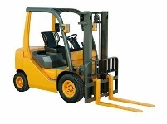 | 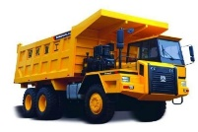
BUS | TELEHANDLER |  |  |  | ROLLAR COMPACTOR | WHEEL LOADER |  |  |  | ROAD GRADER | CONCRETE PUMP
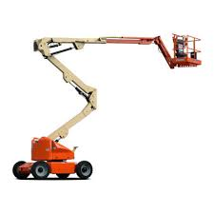 | 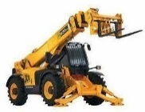 |  |  |  | 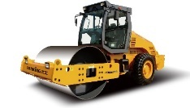 | 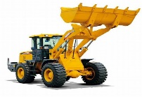 |  |  |  | 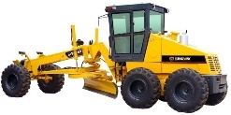 | 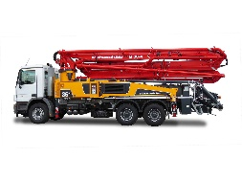
Items |  | Days | Day | Night | Items |  | days | Day | Night | Items |  | Days | Day | Night
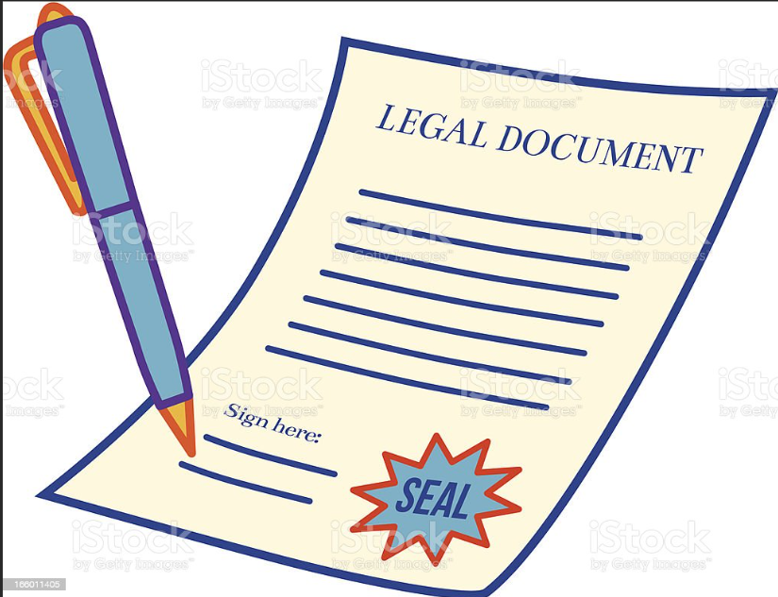 Documents |  | Sat |  |  | 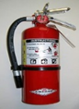  Fire Extinguisher |  | Sat |  |  | 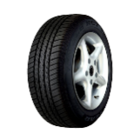  Tires |  | Sat
 |  | Sun |  |  |  |  | Sun |  |  |  |  | Sun
 |  | Mon |  |  |  |  | Mon |  |  |  |  | Mon
 |  | Tue |  |  |  |  | Tue |  |  |  |  | Tue
 |  | Wed |  |  |  |  | Wed |  |  |  |  | Wed
 |  | Thu |  |  |  |  | Thu |  |  |  |  | Thu
 |  | Fri |  |  |  |  | Fri |  |  |  |  | Fri
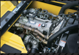 Engine Condition |  | Sat |  |  | 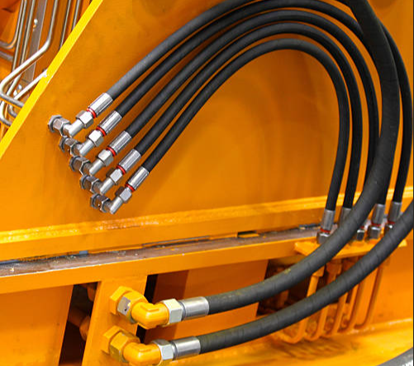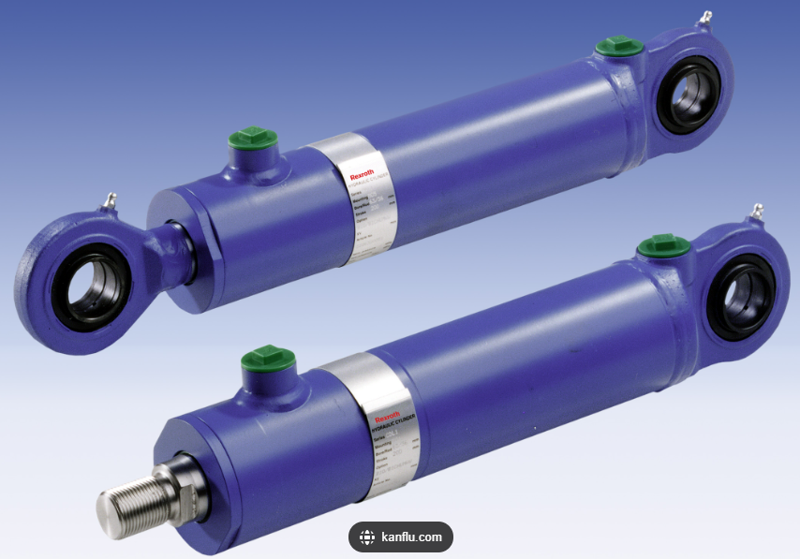  Hydraulic System |  | Sat |  |  | 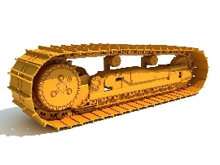  Track Condition |  | Sat
 |  | Sun |  |  |  |  | Sun |  |  |  |  | Sun
 |  | Mon |  |  |  |  | Mon |  |  |  |  | Mon
 |  | Tue |  |  |  |  | Tue |  |  |  |  | Tue
 |  | Wed |  |  |  |  | Wed |  |  |  |  | Wed
 |  | Thu |  |  |  |  | Thu |  |  |  |  | Thu
 |  | Fri |  |  |  |  | Fri |  |  |  |  | Fri
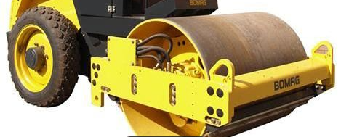Roller Condition |  | Sat |  |  |   Breaking System |  | Sat |  |  | 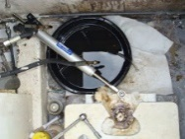  Oil Leakage |  | Sat
 |  | Sun |  |  |  |  | Sun |  |  |  |  | Sun
 |  | Mon |  |  |  |  | Mon |  |  |  |  | Mon
 |  | Tue |  |  |  |  | Tue |  |  |  |  | Tue
 |  | Wed |  |  |  |  | Wed |  |  |  |  | Wed
 |  | Thu |  |  |  |  | Thu |  |  |  |  | Thu
 |  | Fri |  |  |  |  | Fri |  |  |  |  | Fri
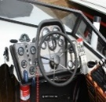Operator Cabin |  | Sat |  |  | 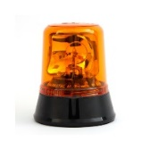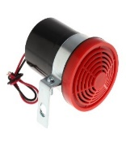  Beacon / Reverse Alarm / Horn |  | Sat |  |  | 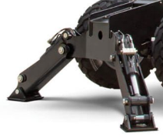  Outrigger / Stabilizer |  | Sat
 |  | Sun |  |  |  |  | Sun |  |  |  |  | Sun
 |  | Mon |  |  |  |  | Mon |  |  |  |  | Mon
 |  | Tue |  |  |  |  | Tue |  |  |  |  | Tue
 |  | Wed |  |  |  |  | Wed |  |  |  |  | Wed
 |  | Thu |  |  |  |  | Thu |  |  |  |  | Thu
 |  | Fri |  |  |  |  | Fri |  |  |  |  | Fri
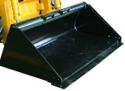 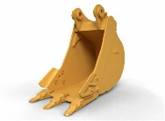 Bucket Condition |  | Sat |  |  | 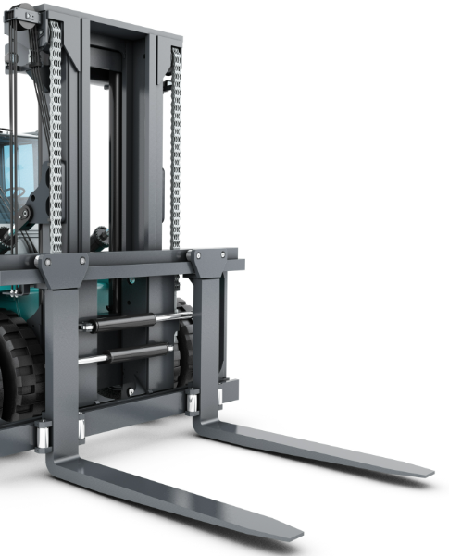  Fork Attachment |  | Sat |  |  | 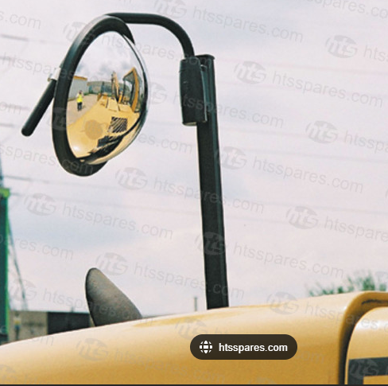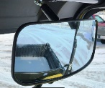  Mirror Condition |  | Sat
 |  | Sun |  |  |  |  | Sun |  |  |  |  | Sun
 |  | Mon |  |  |  |  | Mon |  |  |  |  | Mon
 |  | Tue |  |  |  |  | Tue |  |  |  |  | Tue
 |  | Wed |  |  |  |  | Wed |  |  |  |  | Wed
 |  | Thu |  |  |  |  | Thu |  |  |  |  | Thu
 |  | Fri |  |  |  |  | Fri |  |  |  |  | Fri
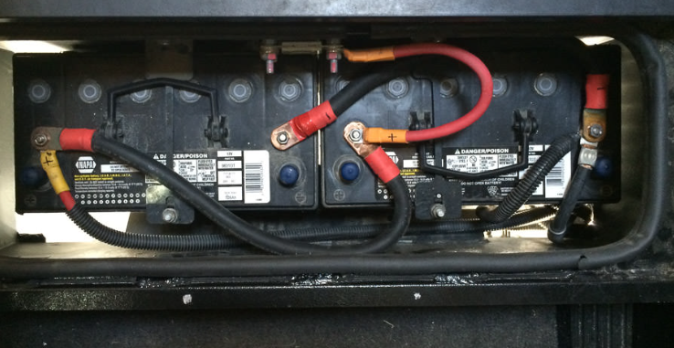 Battery Connection |  | Sat |  |  | 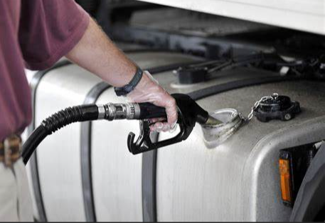  Fuel Tank Condition |  | Sat |  |  |   Seat Belt |  | Sat
 |  | Sun |  |  |  |  | Sun |  |  |  |  | Sun
 |  | Mon |  |  |  |  | Mon |  |  |  |  | Mon
 |  | Tue |  |  |  |  | Tue |  |  |  |  | Tue
 |  | Wed |  |  |  |  | Wed |  |  |  |  | Wed
 |  | Thu |  |  |  |  | Thu |  |  |  |  | Thu
 |  | Fri |  |  |  |  | Fri |  |  |  |  | Fri
Inspected By Operator |  |  |  |  | Day Shift Operator/Signature |  |  |  |  | Night Shift Operator/ Signature

